* *

**Ways to get involved**

**Volunteer**

Volunteers are essential to maintaining the everyday operations of The Arc. Volunteers are needed to help in the office, by being a board member, assisting with fundraising and other projects. Volunteers can also host or attend socials.

**Fundraisers**

The Arc needs the support of the community by participating in our local fundraisers. You can do so by attending our basket bingo, bowling tournament, cell phone drive, or by golfing in our golf tournament. Participants also raise money through our annual Walkathon.

**Newsletter**

The newsletter contains a calendar of events for consumers. It also provides helpful information related to services for persons with developmental disabilities, Arc membership, and on upcoming fundraisers. You may request a newsletter or be put on The Arc’s mailing list. No fee required.

**Socials**

The Socials are held on the third Thursday

of every month at the St. Paul United Methodist Church on Norland Avenue and is listed on the Social Recreation calendar in the newsletter. Please call Arc office to RSVP. Everyone is welcome!

*Please contact the Franklin/Fulton Counties Arc Office if you are interested!*

Franklin & Fulton Counties

**Advocacy & resources for citizens with intellectual and developmental disabilities.**

Arc Traditional Services

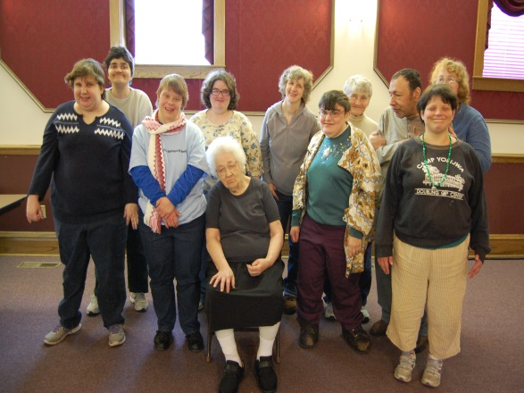

2314 Philadelphia Avenue

Chambersburg, PA 17202

Contact Information:

*Phone: 717-264-4390*

*Fax: 717-264-0348*

*Email:arc4390@embarqmail.com*

*www.thearcoffranklinfultoncounties.com*

**The Arc**



HEADLINE and/or

SUBJECT #1

Delete text and place photo here.

SUBHEAD. SUBHEAD. SUBHEAD.

SUBHEAD. SUBHEAD.

Continue brochure text here. Continue brochure text here. Continue brochure text here. Continue brochure text here. Continue brochure text here. Continue brochure text here. Continue brochure text here. Continue brochure text here. Continue brochure text here. Continue brochure text here. Continue brochure text here. Continue brochure text here. Continue brochure text here. Continue brochure text here. Continue brochure text here. Continue brochure text here. Continue brochure text here.

**Respite Care**

The Respite Care program provides short

term specialized care in or out of the family home and with every aspect of the individual’s daily life. Respite services are direct services to provide relief to families.

**Advocacy**

The Arc of Franklin & Fulton Counties is an advocacy organization helping to ensure individuals with disabilities enjoy the same rights, access to opportunities (educational, employment, community living, health care, etc.), and privileges as other citizens.

**Van Transportation**

Transportation is provided to adult consumers to and from local day programs.

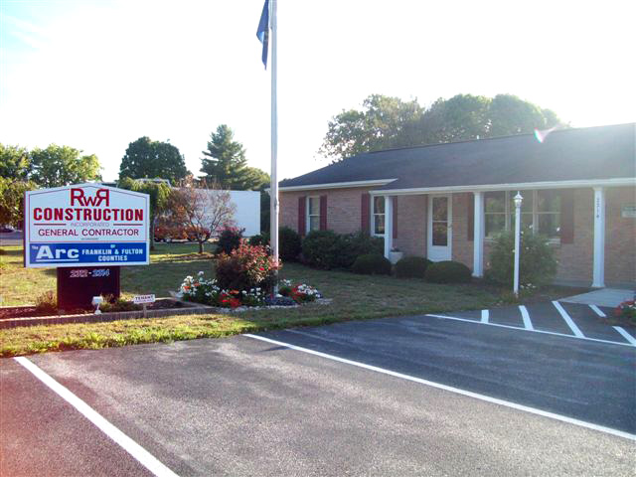

*For more information about these services please contact our office!*

*The Arc is funded through contracts with the Office of Developmental Programs.*

**Programs and Services**

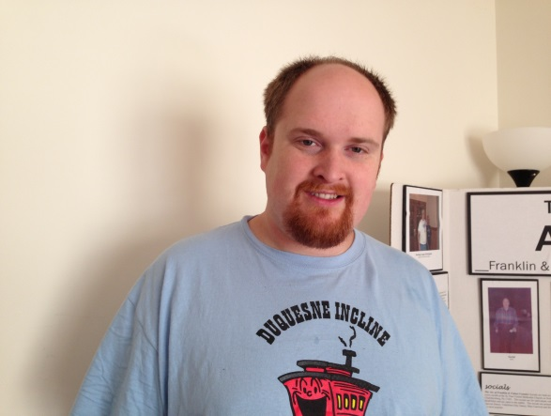

**Companion Services**

Companion Services are provided to

individuals living in private residences for

the purpose of providing supervision

and minimal assistance that is focused on the health and safety of the adult individual

with a developmental disability.

Companion services can provide assistance

in daily living activities including: grooming, healthcare, household care, meal preparation, planning, and socialization. In addition, small group companion services are available.

**Home & Community Habilitation**

Home & Community Habilitation Services are direct services provided in private residences and community settings to protect the health and welfare of individuals and in acquiring, maintaining, and improving self-help, domestic, socialization and adaptive skills.



**About The Arc**

The Arc stands for advocacy & resources for citizens with intellectual and developmental disabilities. The Arc’s purpose is the fostering, protection, and nurturing of the following human rights:

* The right to be a valuable member of society
* The right to a free and appropriate education in an integrated setting.
* The right to live in a comfortable residence in their own local community.
* The right to protection from health and safety hazards in their environment.
* The right to work at a meaningful wage in a vocation appropriate to their talents.
* The right to social and personal relationships.
* The right to participate in the recreational activities of their community.

**The Arc of Franklin & Fulton Counties works toward the goal of assisting people with intellectual and developmental disabilities to fully participate in civil, social, education, health, and employment activities in their home communities which creates the opportunity to grow.**

*The Arc of Franklin-Fulton Counties*

*is a member chapter of The Arc of*

*Pennsylvania and an affiliate of*

*The Arc of the United States.*

SUBHEAD. SUBHEAD. SUBHEAD.

SUBHEAD. SUBHEAD.

SUBHEAD, CONTINUED ONTO THE

NEXT LINE IF NECESSARY

Continue brochure text here. Continue brochure text here. Continue brochure text here. Continue brochure text here. Continue brochure text here. Continue brochure text here. Continue brochure text here. Continue brochure text here. Continue brochure text here. Continue brochure text here.

Continue brochure text here. Continue brochure text here. Continue brochure text here. Continue brochure text here. Continue brochure text here.

HEADLINE and/or

SUBJECT #3

HEADLINE and/or

SUBJECT #2

Continue brochure text here. Continue brochure text here. Continue brochure text here. Continue brochure text here. Continue brochure text here. Continue brochure text here. Continue brochure text here. Continue brochure text here. Continue brochure text here. Continue brochure text here. Continue brochure text here. Continue brochure text here.

SUBHEAD

Continue brochure text here. Continue brochure text here. Continue brochure text here. Continue brochure text here. Continue brochure text here. Continue brochure text here. Continue brochure text here. Continue brochure text here. Continue brochure text here. Continue brochure text here. Continue brochure text here. Continue brochure text here. Continue brochure text here. Continue brochure text here. Continue brochure text here. Continue brochure text here. Continue brochure text here.